Due Date and Time: Sep 25th 2022, 11.59 PM in D2L.

Q1. A company database needs to store information about employees (identified by *ssn*, with *salary* and *phone* as attributes), departments (identified by *dno*, with *dname* and *budget* as attributes), and children of employees (with *name* and *age* as attributes). Employees *work* in departments; each department is *managed by* an employee; a child must be identified uniquely by *name* when the parent (who is an employee; assume that only one parent works for the company) is known. We are not interested in information about a child once the parent leaves the company. Draw an ER diagram using CROW’s Foot or UML Notation that captures this information. **[10 Marks]**

Q2. Consider the ER diagram of online sales system above. Based on the diagram answer the questions below,

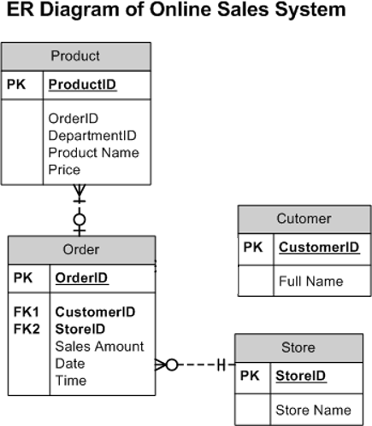

1. Based on the ER Diagram, determine the Foreign Key in the Product Table. Just mention the name of the attribute that could be the Foreign Key. **[2 Marks]**

**A: DepartmentID**

1. Mention the relationship between the Order and Customer Entities. You can use the following:

# [4 Marks]

1:1, 1:M, M:1, 0:1, 1:0, M:0, 0:M

**A: Relationship between Customer and Order table can be described as 0:M and 1:1. Customers can have 0 to Many orders, but orders must have 1 customer related to the order.**

1. Is there a direct relationship that exists between Store and Customer entities? Answer Yes/No?

**[1 Mark]**

**A: No**

1. Which of the 4 Entities mention in the diagram can have a recursive relationship? **[1 Marks]**

**A: Customers can have a recursive relationship if the online sales system has a referral system for customers to refer another customer.**

1. If a new entity Order_Details is introduced, will it be a strong entity or weak entity? If it is a weak entity, then mention its type? **[2 Marks]**

**A: It will be considered a weak entity and a exclusive subtype.**